Date | 27 June 2026
Team ID
Project Name | Leave Approval System
Maximum Marks
Project Development Phase

1. Introduction
The Student Leave Automation System was developed as a scoped application on the ServiceNow platform. The objective of the implementation phase was to automate the student leave approval process by replacing manual paperwork with a centralized workflow. The application provides separate interfaces for students and faculty, role-based access control, workflow automation, and email notifications.

2. Milestone 1 – Application Setup
Objective
Create the scoped application and initialize the project.
Activities Performed
- Created a new scoped application.
- Configured the application menu and modules.
- Prepared the development environment.
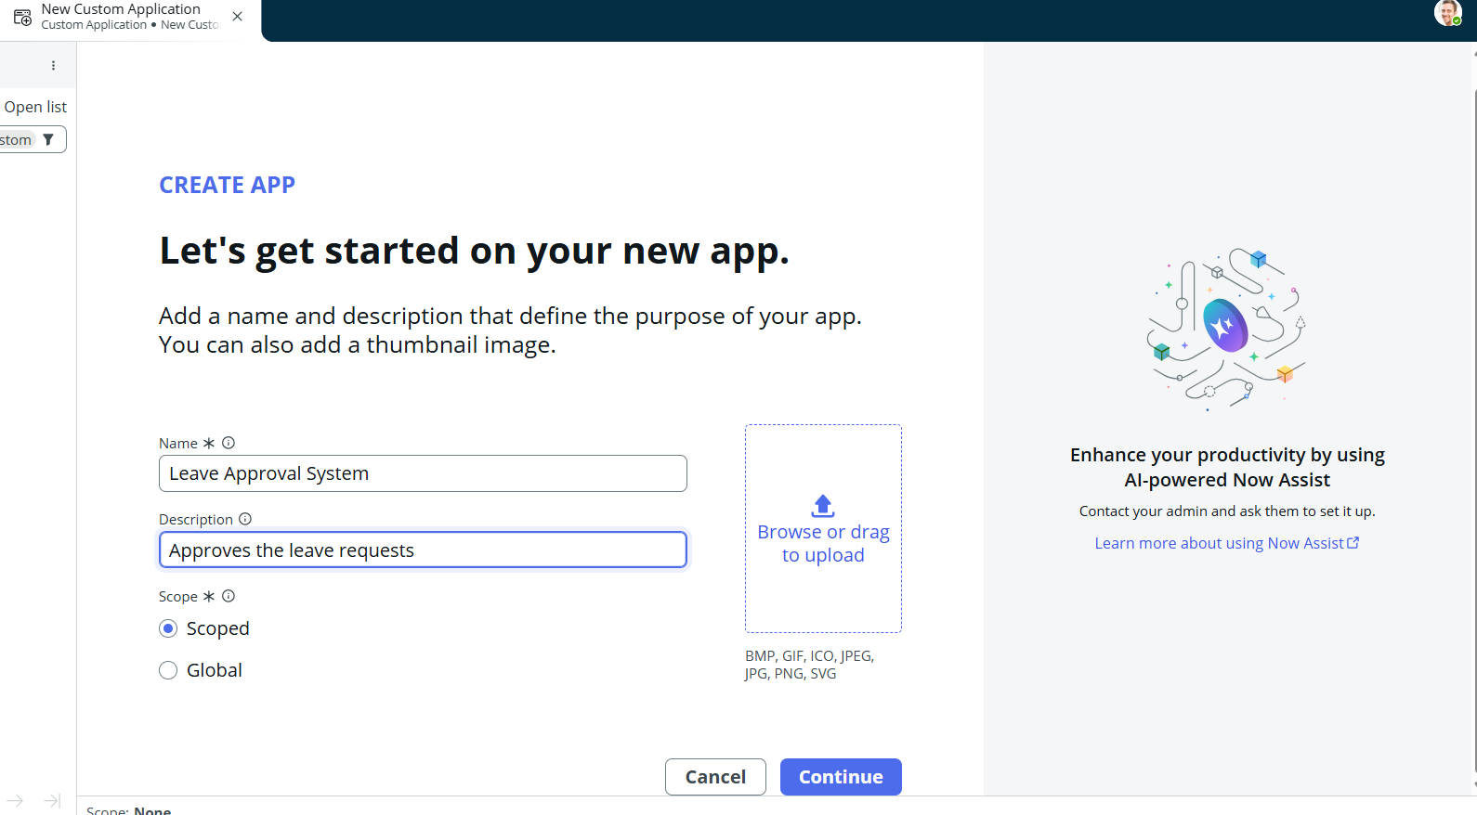

3. Milestone 2 – Database Configuration
Objective
Create the Leave Request table for storing leave applications.
Activities Performed
- Designed the Leave Request table.
- Added fields such as Employee, Leave Type, Start Date, End Date, Reason, Status, Manager Comments, and Approval Date.
- Configured reference fields to the ServiceNow Users table (sys_user).
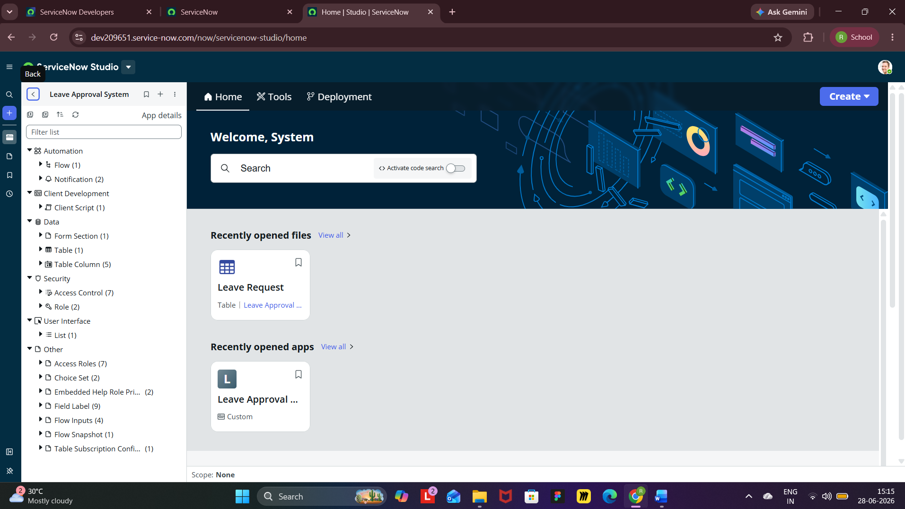
4. Milestone 3 – User & Role Configuration
Objective
Configure users and application roles.
Activities Performed
- Created Employee user accounts.
- Created Manager user account.
- Assigned Employee role to employees.
- Assigned Manager and Administrator roles to authorized users.
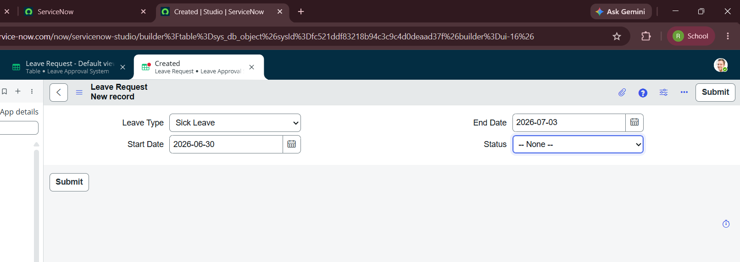
5. Milestone 4 – User Interface Development
Objective
Develop user-friendly interfaces for students and faculty.
Activities Performed
- Designed the Employee Leave Request form.
- Configured separate Employee and Manager view.
- Implemented UI Policies for dynamic form behavior.

6. Milestone 5 – Workflow Automation
Objective
Automate leave approval and notification process.
Activities Performed
- Developed a Flow Designer workflow.
- Triggered the workflow whenever the leave status changes.
- Configured email notifications for Approved and Rejected leave requests.
- Automatically updated leave request status.

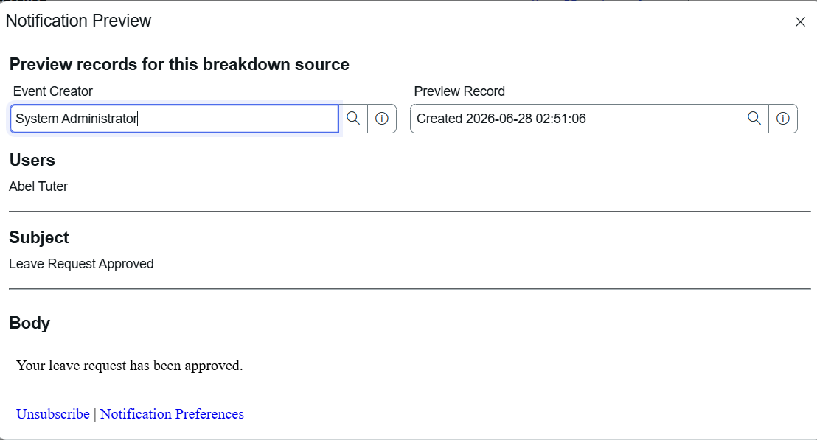
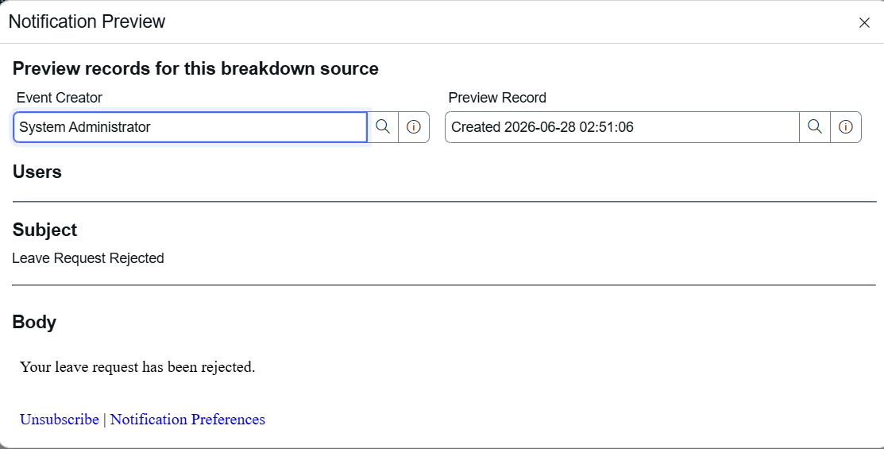
7. Milestone 6 – Application Testing
Objective
Validate the end-to-end functionality of the application.
Test Scenario 1
Employee submits a leave request.
Expected Result:
Leave request is created successfully.
Status:
Passed
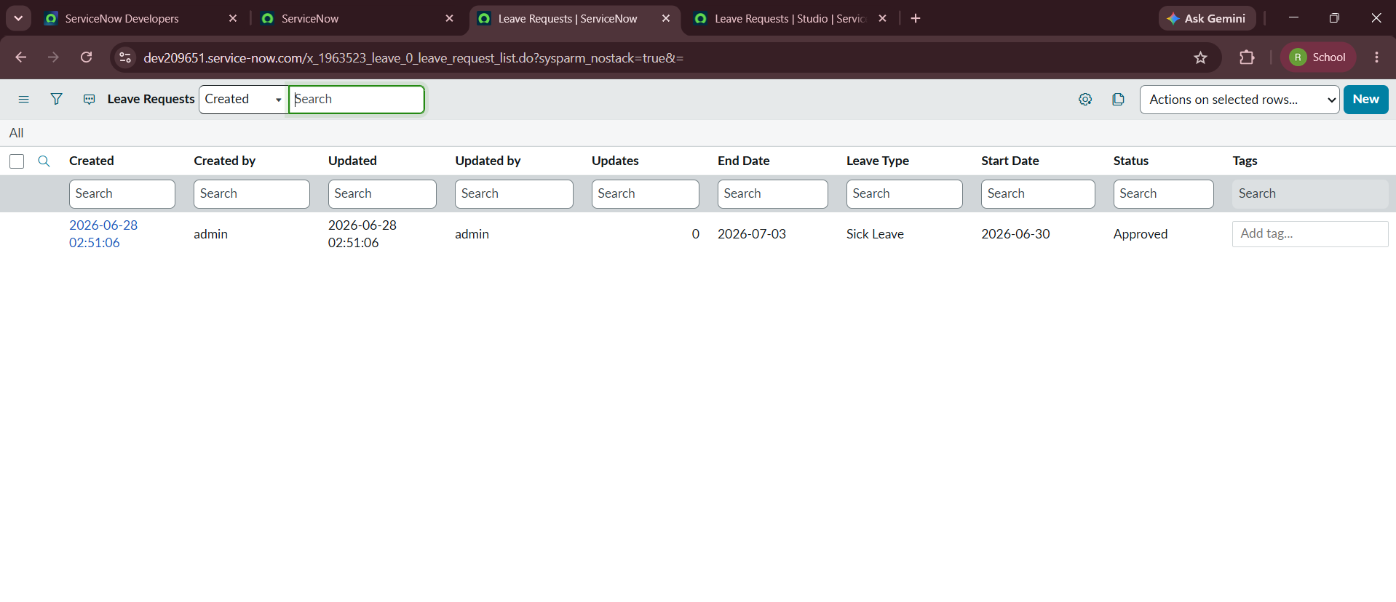

Test Scenario 2
Manager approves a leave request.
Expected Result:
Status changes to Approved and an email notification is sent to the employee.
Status:
Passed

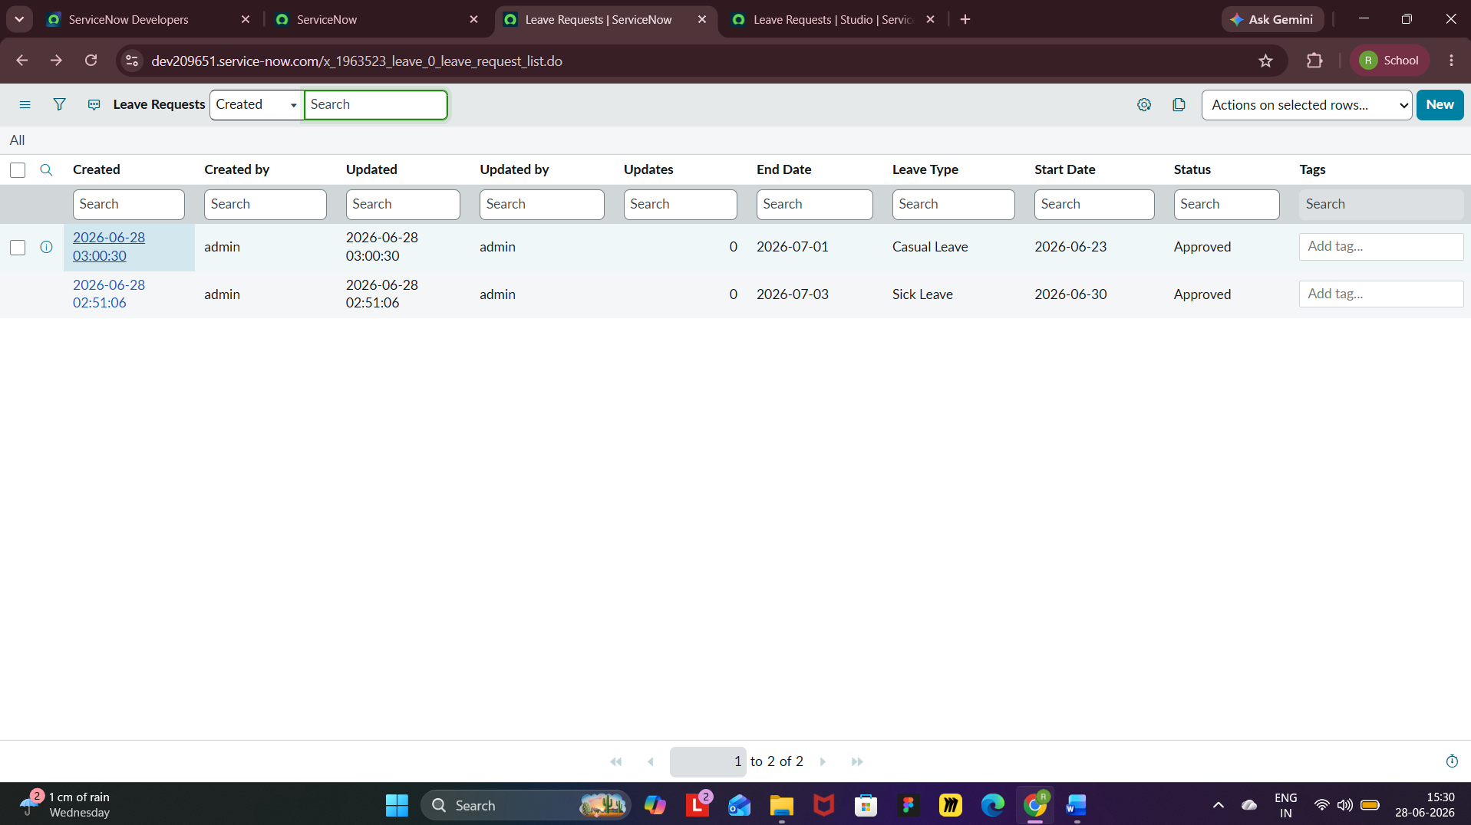

Test Scenario 3
Manager rejects a leave request.
Expected Result:
Status changes to Rejected and an email notification is sent to the employee.
Status:
Passed

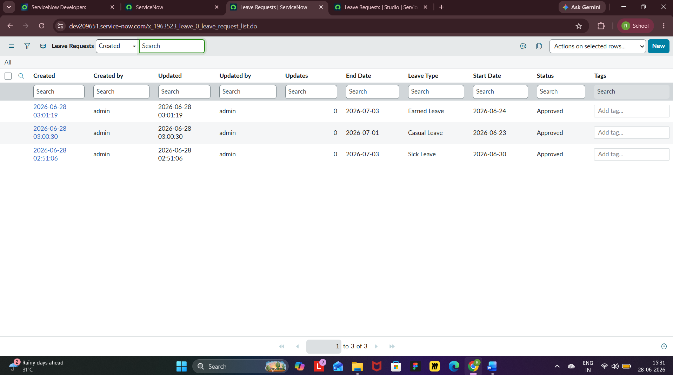

Test Scenario 4
Role-based access testing.
Expected Result:
Employees can access only their own leave requests, while managers can view and manage assigned requests.
Status:
Passed
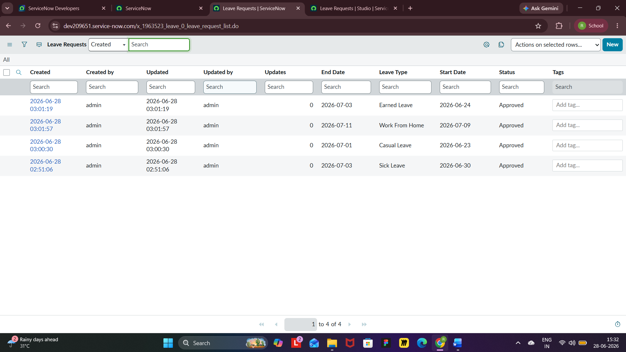

8 Development Summary
The Leave Approval System successfully implements a centralized leave management workflow using the ServiceNow platform. The application provides secure role-based access, employee leave request submission, manager approval and rejection, workflow automation using Flow Designer, email notifications, and centralized leave record management. All functional requirements were successfully implemented and validated through testing.

